**OVMS**

**Open Vehicle Monitoring System**



[www.openvehicles.com](http://www.openvehicles.com/)

**Tesla Roadster (v1.x and v2.x)**

**Guide v1.2.6 (7th June 2012)**

**History**

v1.2.6 7th June 2012 Various clean-ups

v1.2.5 30th May 2012 New SMS commands in firmware 1.3.0

v1.2.4 20th May 2012 Pre-installation chapter, updated photos

v1.2.3 7th May 2012 Reorganization to be more install-time linear

v1.2.2 1st Apr 2012 Updates to match v1.2.2 car firmware

v1.2 12th Mar 2012 Updates to match v1.2 car firmware

v1.0 10th Jan 2012 Initial version written

# Welcome

The OVMS (Open Vehicle Monitoring System) team is a group of enthusiasts who are developing a means to remotely communicate with our cars, and are having fun while doing it.

The OVMS module is a low-cost hardware device that you install in your car simply by installing a SIM card, connecting the module to your car’s Diagnostic port connector, and positioning a cellular antenna. Once connected, the OVMS module enables remote control and monitoring of your car.

There are two ways for you to communicate with the OVMS module:

1. Send text messages from a cell phone to the OVMS module’s phone number. The module will respond back via text messaging. If you want, the OVMS module can also send text messages to you when the car reaches certain states, such as if charging is interrupted.
2. Use a smartphone App. Both the OVMS module and the App communicate with an OVMS server via UDP/IP or TCP/IP over the Internet. The smartphone Apps provide a richer experience and more functionality, but they do require a data plan on the SIM car you purchase and install in the OVMS module.

This Guide will help you setup and configure your OVMS module. Initial configuration of the OVMS module is done via SMS. Once configured, you can use either SMS and/or the cellphone Apps to communicate with the OVMS module.

 **Warning!**

*OVMS is a hobbyist project, not a commercial product. It was designed by enthusiasts for enthusiasts. Installation and use of this module requires some technical knowledge, and if you don't have that we recommend you contact other users in your area to ask for assistance.*

The OVMS module is continuously powered by the car, even when the car is off, but it uses very little power (especially compared to the Tesla Roadster's 53KWh battery pack).

 **Warning!**

*While the OVMS module uses extremely low power, it does continuously draw power from the car’s battery, so it will contribute to 'vampire' power drains. Do not allow your car battery to reach 0% SOC, and if it does, plug in and charge the car immediately. Failure to do this can result in unrecoverable failure of the car’s battery.*

Table Of Contents

Welcome 3

The OVMS Module 5

Cellular Service and SIM card Choices 5

Pre-Installation Steps 6

A. Understand Configuration Parameters 6

B. Obtain and Activate a GSM SIM card 7

C. Obtain a User Account on OpenVehicles.com 7

D. Register the Car’s VehicleID and OVMS Server Password 7

OVMS Module Installation 8

1. Install the SIM card 8

2. Enable or Disable GPRS Data access 9

3. Connect the GSM antenna 10

4. Understand OVMS Module LED Light Codes 11

5. Connect the OVMS module to the car 12

6. Register your cell phone with the OVMS Module 14

7. Change the OVMS Module Password 15

8. Configure the Module’s Identify, Units, and Notification Mechanism 16

9. Configure the Server Connection (Needed for smartphone App usage) 17

10. Configure the GPRS Data Connection (Needed for smartphone App usage) 18

11. Troubleshooting the Module to Server Connection 19

12. Installing the OVMS App for your smartphone. 20

13. Configuring the iPhone OVMS App 20

14. Enable Car Control 22

15. Identify your car as a v1.5 Tesla Roadster 22

16. Share your Location using Social Groups 23

17. Mount the OVMS Module 24

18. Locate the Antenna and Routing the Antenna cable 25

Appendices 28

Appendix A – SMS Commands 28

Appendix B – Feature List 30

Appendix C – Parameter List 31

## The OVMS Module

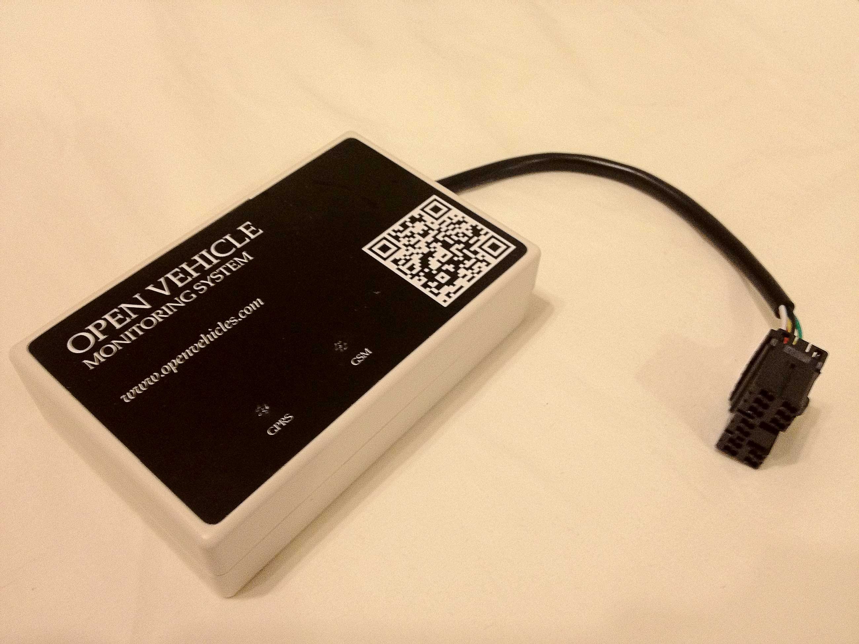

The OVMS module contains a low-power micro-controller control board and a GSM cellular modem. It plugs into the car's diagnostics port (from where it receives power and listens to the car's internal communications), and provides monitoring and control functions via either SMS messages or smartphone Apps (over the Internet).

## Cellular Service and SIM card Choices

Prior to installation in the car, you will need to purchase a pre-activated full-size SIM card that uses a GSM cellular network and install it in the OVMS module.

# Pre-Installation Steps

Before you physically install the OVMS module, you should understand and then perform the following steps:

## A. Understand Configuration Parameters

A number of accounts and passwords are required for OVMS to function, especially if you intend to use a smartphone App (which is something we recommend). It’s important to understand the various pieces of data involved before beginning installation:

**VehicleID** – This is how the OVMS server identifies your car as distinct from other cars. You get to make this up, but it has to be unique from any other car. If you participate in a Social Group, this will be the name displayed next to your car on the map. VehicleID must contain only uppercase letters and numbers.

**OVMS Module Password** – Normally, the OVMS module uses callerID to recognize a cell phone you register as authorized to communicate. This password enables you to use any cellphone or SMS service to send text messages to the OVMS module. The default is “OVMS,” but we strongly recommend you change it to something of your own choosing.

**OVMS Server Password** – This is a shared secret between the OVMS server, your car, and your smartphone App. You get to make this password up.

**OpenVehicle Username** & **OpenVehicle Password** – These are the credentials you use to log into the OpenVehicles.com web site. You probably already used them to log on to order your hardware module. You get to choose your OpenVehicle Username and OpenVehicle Password.

**Cellular Network APN**, **Cellular Network Username**, & **Cellular Network Password** – Your cellular carrier uses these to establish and authorize the GPRS (internet) connection from the OVMS module to the cellular network. You should ask your cellular provider for these values when you purchase your SIM card.

Note that there are 2 usernames and 4 passwords involved. Throughout this document and in the various smartphone App settings we will use the explicit names listed. We suggest you write down your values below, and keep this document in a safe place:

**VehicleID: _____________________________**

**OVMS Module Password: _____________________________**

**OVMS Server Password: _____________________________**

**OpenVehicle Username: _____________________________**

**OpenVehicle Password: _____________________________**

**Cellular Network APN: _____________________________**

**Cellular Network Username: _____________________________**

**Cellular Network Password: _____________________________**

## B. Obtain and Activate a GSM SIM card

The OVMS module supports the GSM network only, NOT the CDMA network nor iDEN. In the US, both AT&T and T-Mobile use GSM, and so are suitable. Note that Sprint, Verizon, MetroPCS, US Cellular, and Nextel in the US are NOT suitable. Most of Europe uses GSM.

If you only wish to use text message control, then you only need an SMS messaging plan. If you wish to use smartphone Apps to control the car (recommended), then you will need a GPRS data plan. Note that even if you plan to use smartphone App exclusively, you will need to send and receive several text messages during initial setup.

For typical App usage, we estimate that you will only need around 2MB a month for data usage, but that can vary by user. Note that if you enable the location streaming feature you will use more data. The smartphone Apps help you monitor your usage.

You will need to pre-activate the SIM card (usually by placing it in a normal cellular telephone and going through whatever steps your cellular provider requires to activate the service). You cannot activate the SIM card in the OVMS module. Also, make sure the SIM card is not Locked (aka PIN protected).

You should write down the telephone number that your cellular carrier has allocated to the SIM card. If you are using GPRS data you will also need the carrier’s Cellular Network APN, Username and Password for GPRS service. Sometimes the Cellular Network Username and Password are not required, but that is carrier dependent. Many carriers also provide online usage monitoring of your account, but OVMS does not tie into that.

## C. Obtain a User Account on OpenVehicles.com

If you haven’t done so already, visit <http://www.OpenVehicles.com> and register for a user account. If you purchased an OVMS module online, you probably logged into this account to order your module. This will be your **OpenVehicle Username** and **OpenVehicle Password**. If you intend to use Text Messaging only to communicate with the OVMS module, this step is not needed. It is needed for smartphone App access, which provides not only a more intuitive interface, but also enables more functionality.

## D. Register the Car’s VehicleID and OVMS Server Password

Send an email to [***info@OpenVehicles.com***](mailto:info@OpenVehicles.com) that includes:

1. Your **OpenVehicle Username** from Step C, above.
2. The **VehicleID** you want to use. For Tesla Roadsters, this is typically a country abbreviation followed by the last 4 digits of your car’s VIN, for instance: **US1007**.
3. The **OVMS Server Password** you want to use.

If you intend to use Text Messaging only to communicate with the OVMS module, this step is not needed. It is needed for smartphone App access.

# OVMS Module Installation

## 1. Install the SIM card

Before opening the OVMS module box, scribe a pencil mark across both halves. You will use this mark to ensure that you reassemble the box in the correct orientation (otherwise the LEDs won’t be visible). Remove the four screws on the underside and open the two halves of the box.

The SIM card holder is located on the modem board (which is the larger of the two boards and is on the bottom). In the photo below the holder is outlined in red and is in the closed and locked position with a SIM card installed:

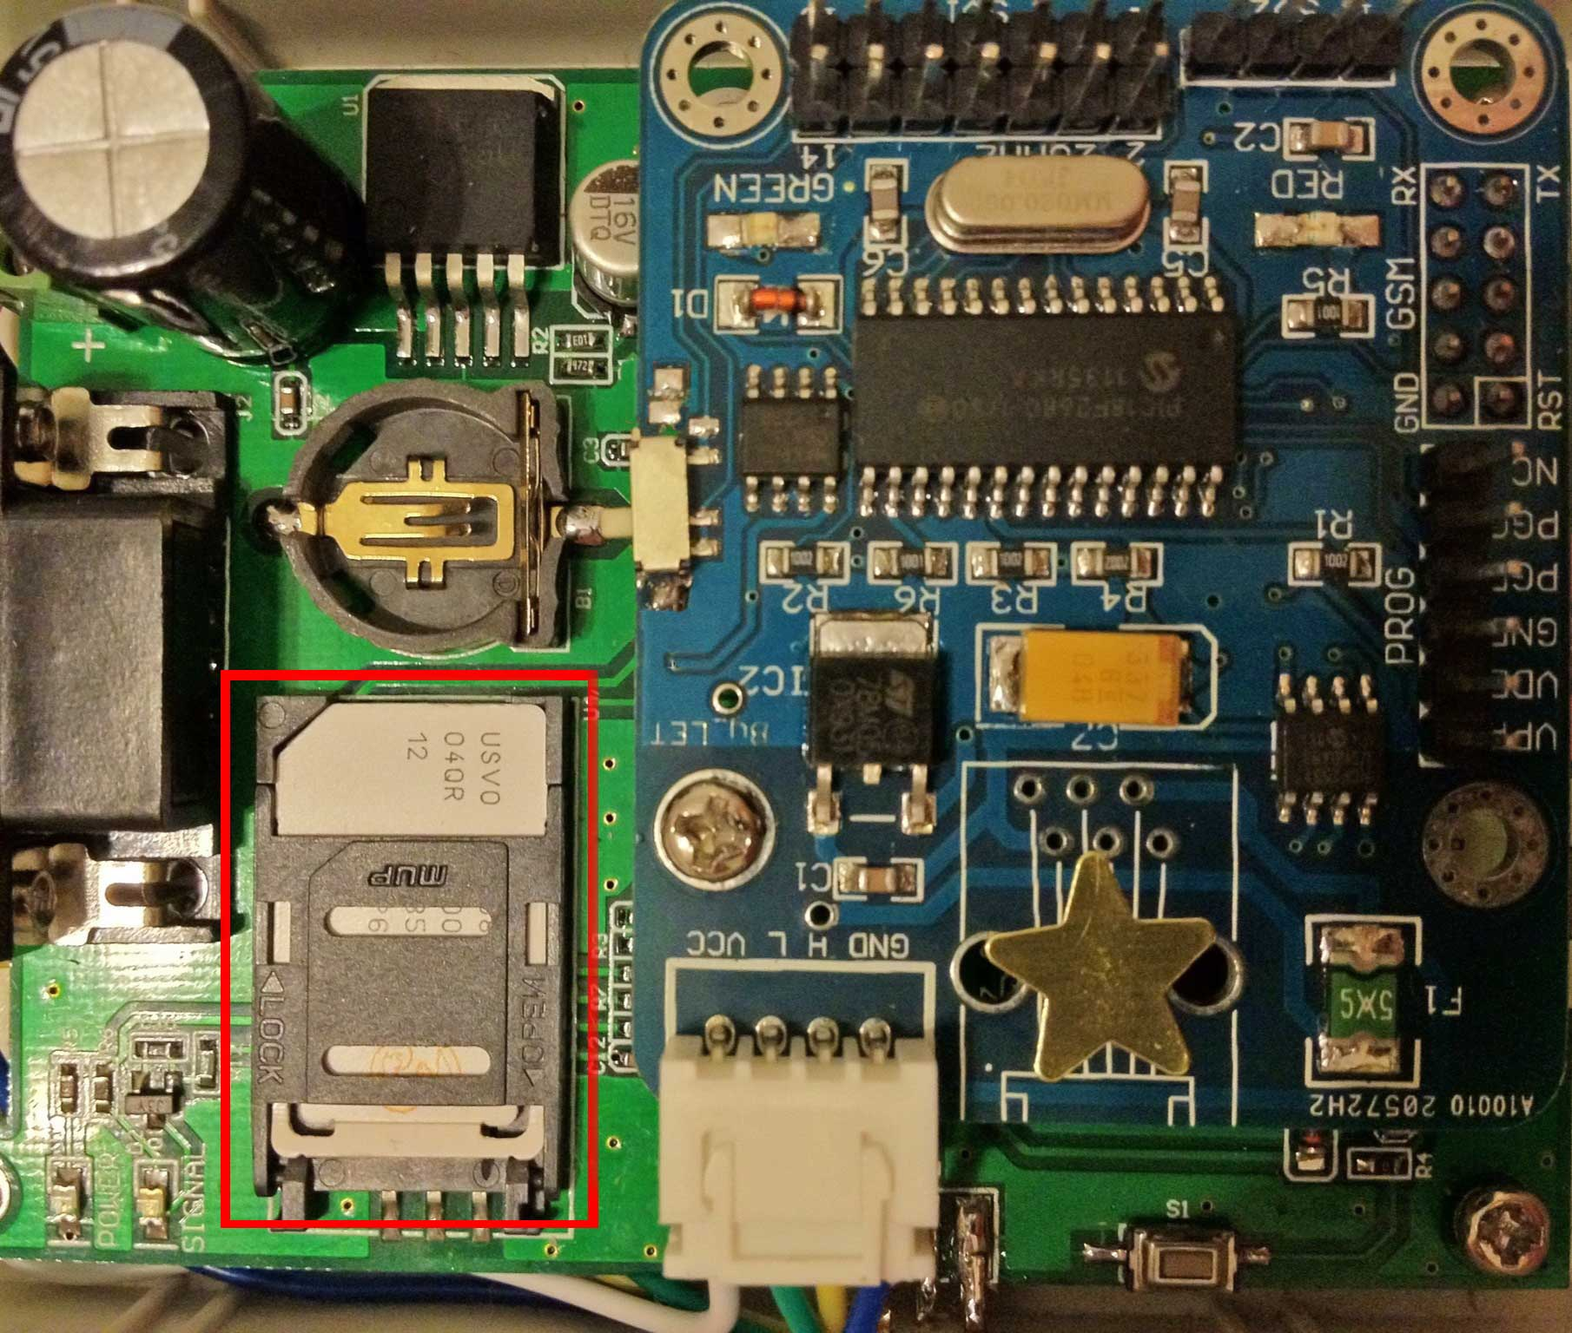

Look closely at the holder to identify where the cut-off corner of the SIM card should go. Slide the holder in the direction indicated by “OPEN” imprinted on it, then pivot the holder up. Slide the SIM card into the card holder, taking into account where the cut-off corner should be located. It should look like the photo below:

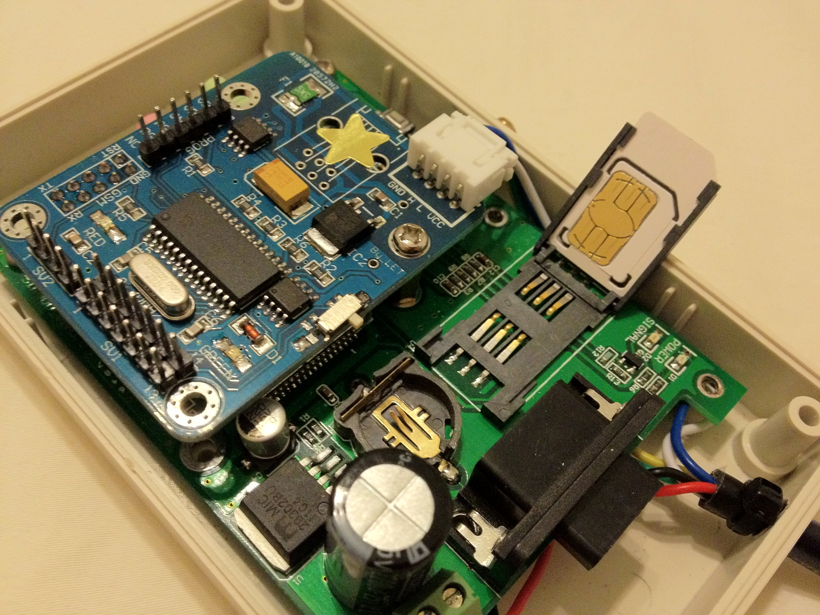

Now pivot the holder down until it’s flush with the circuit board, then slide the holder in the direction labelled “LOCK” on it.

## 2. Enable or Disable GPRS Data access

The OVMS module includes a hardware switch that enables or disables the GPRS data mode, which is used by the smartphone Apps. The switch is on the main board (which is on top and smaller) along the inside edge. See the red arrow in the photo at the top of the next page.

Sliding the switch towards the LED lights will disable GPRS data. Sliding it towards the power connection will enable GPRS data. If you will *solely* be using text messages to communicate with the OVMS module, then you should slide the switch to disable GPRS data communication. If you will be using a smartphone App, then make sure the switch is set to enable GPRS data communication.

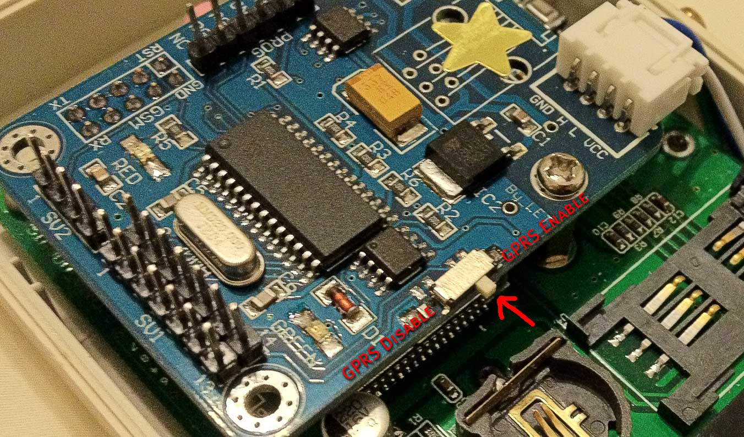  *GSM Only / GPRS Enable Switch*

This switch is also useful if you need to diagnose problems connecting to the OVMS server. For instance, if an incorrect Cellular Network APN/Username/Password combination has been entered, the OVMS module will continuously try to establish GPRS communications, and so may not respond to text messages. The solution to this is to slide the switch to the GPRS Disable position. You can then fix the network settings via text messages and then re-enable GPRS.

If the OVMS module is connected to the car, you must reboot the module after changing the switch position. This is done either by unplugging the module, waiting several seconds, and reconnecting, or by sending the SMS command “ RESET ” to the module

Now you can close the OVMS box, making sure to align the pencil marks you previously made, and tighten the four screws. Please take care not to over-tighten these screws, as they screw into plastic threads. We recommend that you loosen/tighten these screws manually - don't use a power screwdriver for this.

## 3. Connect the GSM antenna

The OVMS module comes with an adhesive-backed GSM antenna designed to provide excellent cellular service. It has a long cable to enable various placement options. The antenna has a center pin that inserts inside a hole in the exposed threads on the OVMS module box. Then tighten the locking nut – by hand should be fine. Be sure not to bend the center pin of the cable when installing.

For now, lay the end of the antenna somewhere exposed so that it gets a good signal.

## 4. Understand OVMS Module LED Light Codes

The OVMS module has two LED lights. When the OVMS module is connected to the car, it will go through a start-up sequence, which is reported through its LED lights as follows:

1. The RED light will come on solid and the green light will blink the module’s firmware version as a set of 3 sequences, each separated by a pause. For example, 1.2.7 will be 1 blink then a pause, then 2 blinks then a pause, then 7 blinks)
2. The GREEN light will blink out a countdown of the boot-up sequence, as follows:

10 – Waking up the modem

9 – Checking for presence of SIM card

8 – Checking SIM card and lack of PIN lock

7 – Initializing the modem

6 – COPS initialization (trying to connect to a cellular tower)

5 – GPRS Network initialization

4 – GPRS APN is OK (Initialization complete)

3 – GPRS Network call is made

2 – GSM is Ready

1 – GPRS is Ready

Since GPRS has not yet been configured, the first sequence will end with 2 blinks.

C) Should an error occur, the RED light will blink out an error code, as follows:

1 – Lost signal

2 – Cannot communicate with modem

3 – SIM card is missing, not inserted properly, or not detected

4 – SIM card has a PIN lock

6 – COPS GSM lock could not be obtained

7 – Error during GPRS initialization (might be temp related)

8 – GPRS Network initialization failed

Note that in case of an error, the Green light will still be blinking its state concurrently with the Red light blinking out its code. For instance, if the SIM card has a PIN lock the Green light may be blinking 8 times while the Red light may be blinking 4 times. This will look like both Red and Green blinking 4, following by Red blinking another 4 (to make 8). You may want to hide light with your finger to help you count properly.

Sometimes during bootup, the module will need to reset the modem. If this occurs, both the Red and Green lights will come on for as long as it takes to reset the modem, which is typically a second or two. This is nothing to worry about.

## 5. Connect the OVMS module to the car

The OVMS module is connected to your Roadster via the CAN bus diagnostic port connector, which is located in the passenger footwell. It is made of plastic that is wrapped in grey foam, as shown in the photo on the next page. Typically, the connector is wedged into the front wall near the center console so it won’t rattle. Pull the connector out and note the orientation of the pins, especially the void above the +12V and Ground pins. See the photo below.

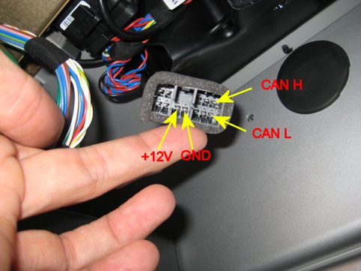

*Tesla Roadster DIAG port connector*

It will be more convenient to leave the OVMS module on the floor for now so that you can monitor the LED light sequence when it is first connected.

 **Warning!**

*If, when you plug the OVMS into the car, you see any interference to, or strange behaviour of, car systems – immediately unplug the module and contact Open Vehicles for assistance. Never leave a module connected in such circumstances.*

Ensure that the car is turned off (remove the key!), orient the OVMS module’s connector to the car’s connector appropriately, and slide them together until you feel/hear them snap into place.

You should immediately see the Red light come on, with the Green blinking out the firmware version, as described Step 4A, above. Then, the Green light will blink out the bootup sequence countdown, as described in Step 4B, above, When you eventually see a solid GREEN light, your OVMS Module is ready to receive and send Text Messages. Otherwise, count the red flashes to determine the error.

At this point, check the car. Tap on the VDS in the centre console and make sure it turns on. Insert the key, turn on the car, and make sure everything works as expected. If you see any problems at all with the car, disconnect the OVMS module and contact support@OpenVehicles.com for assistance.

Suggestions for mounting the OVMS module, positioning the cellular antenna, and routing the wires are provided later in this document. The photo below shows an OVMS module connected to the CAN bus and mounted to the front wall:

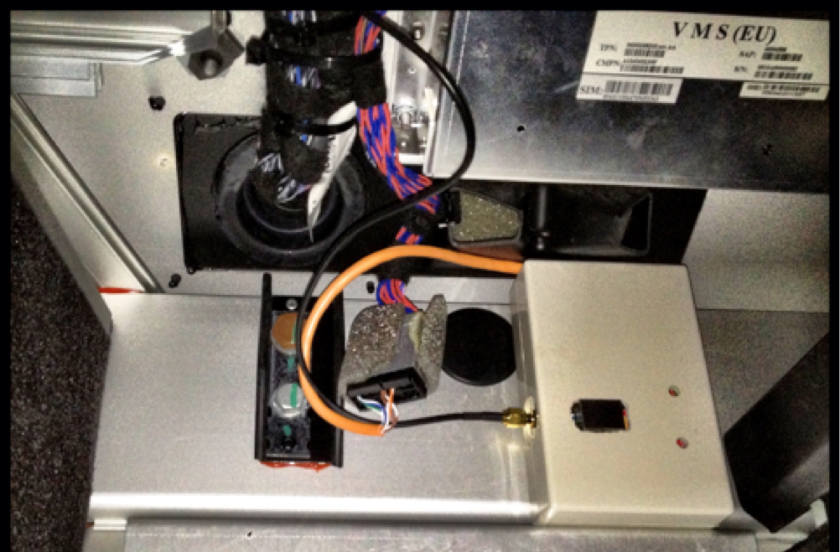

*Position of the module in the passenger footwell*

## 6. Register your cell phone with the OVMS Module

By registering a cell phone with OVMS, that phone can then send commands to the OVMS module without needing to supply the OVMS Module Password. For security purposes, to send commands from other cell phones (or any SMS send-capable device/website), you’ll need to supply the OVMS Module Password.

For your convenience, we recommend creating an Address Book entry in your cell phone for your car using the phone number of the SIM card you installed. Give it a descriptive name. To register your cell phone with OVMS, send the following Text Message to the car, exactly as follows:

REGISTER OVMS

Note that “OVMS” is the default OVMS Module Password, and that the “REGISTER” command must be all uppercase.

If all is well, within a few seconds OVMS will Text Message you back with:

Your phone has been registered as the owner.

At this point, the telephone number of your phone has been registered and remembered by the OVMS module. You don't need the OVMS Module Password to talk to the car from this cell phone, as the car will use CallerID to recognize it.

## 7. Change the OVMS Module Password

You should now change the default OVMS Module Password to one of your own choosing.

Choose a password between 4 and 22 characters in length, with no spaces. The OVMS Module Password is case-sensitive. Write it down in the space on page 6 of this manua.

To set it, send a Text Message to the car from the registered cell phone, as follows:

PASS *MYNEWPASSWORD*

(obviously replacing *MYNEWPASSWORD* with the secret password of your choice)

If all is well, within a few seconds the car will reply back with:

Module password has been changed.

At this point, you have Text Message monitoring of the car!

One useful query you can send to the car is:

STAT?

This will result in OVMS sending you back a Text Message back with Charge Mode, Charge Status, Ideal Range, and SOC (Battery State of Charge), for instance:

Standard – Charging Done

Ideal Range: 300 km

SOC: 96%

Another query you can send is:

GPS?

This will result in OVMS sending you back a Text Message containing a Google Maps link that will show you the location of the car.

Note that queries end with a question mark – that is you assurance that the SMS will not change any settings in the OVMS Module.

If you want to send queries (and some commands) from a different cell phone than the Registered phone, simply add the OVMS Module Password as the last parameter, for instance:

STAT? *MYNEWPASSWORD*

GPS? *MYNEWPASSWORD*

If you forget your OVMS Module Password and have lost this document, you can query it from the registered cell phone by sending the following query:

PASS?

After a few seconds, you should get a response back telling you the Module password.

See Appendix A for a complete list of SMS commands.

## 8. Configure the Module’s Identify, Units, and Notification Mechanism

You may have noticed that your Module’s response to STAT is in kilometres. That is the default. Changing this, as well as enabling notifications, is done via the MODULE command. This can be sent only from the Registered cellphone (see Step #5). There are 3 parameters to be set, as follows:

1. Vehicle ID

This is the name you registered with OpenVehicles.com during pre-installation Step D, on page 7, and wrote down on page 6.

1. Distance units

M to display ranges in miles (and temperatures in Fahrenheit)

K to display ranges in kilometres (and temperatures in Celsius)

1. Notification Mechanism(s). There are 4 choices:

SMS to have the module send an SMS message to the registered phone when an event such as charging being interrupted occurs.

IP to have notifications received via a smartphone App.

SMSIP to enable both SMS and smartphone App notifications.

- (dash character) if you don’t want any notifications sent

An example of a valid MODULE command is:

MODULE US1007M SMSIP

If all is well, within a few seconds the car will Text you back with:

Parameters have been set.

If you want to confirm what your MODULE settings are, send the following query::

MODULE?

The response will be similar to:

Module:  
 VehicleID:US1007

Units:M

Notifications:SMSIP

## 9. Configure the Server Connection (Needed for smartphone App usage)

If you don’t want to use a smartphone App to control the car, you can skip Steps 9-13, and proceed to configure Car Control, which is described in Step 14.

Configuring of the Server Connection is done via the SERVER Text Message command. This can be sent only from the Registered cellphone (see Step #5). There are 3 parameters to be set, as follows:

1. OVMS Server IP address

This is the IP address of the OVMS server you want to use. The Tesla Motors Club has graciously agreed to provide a server free of charge to OVMS users (see <http://www.teslamotorsclub.com/showthread.php/7705-PR-OpenVehicles-com-selects-Tesla-Motors-Club-as-technology-partner?p=118126&viewfull=1#post118126>). That IP address is **64.111.70.40**.

If you wish you can use another server, in which case you’ll need to contact info@openvehicles.com for information on how to configure your own server.

Note that you will need to tell your smartphone App to use the same server you specify here.

1. OVMS Server Password

This should have been obtained via Pre-installation step D, and written down on Page 6.

1. Paranoid mode:
   1. “P” will enable this mode
   2. “-“ will disable this mode

When enabled, the server is unable to decode the messages being relaying

between the OVMS Module and your smartphone Apps.

An example of a proper SERVER command is:

SERVER 64.111.70.40 MyOVMSServerPassword -

If all is well, within a few seconds the car will Text you back with:

Parameters have been set.

If you want to confirm what your SERVER settings are, send the following query::

SERVER?

The response will be similar to:

Server:  
 IP:64.111.70.40

Password:MyOVMSServerPassword

Paranoid:-

## 10. Configure the GPRS Data Connection (Needed for smartphone App usage)

If you don’t want to use a smartphone App to control the car, you can skip Steps 9-13, and proceed to configure Car Control, which is described in Step 14.

 **Warning!**

*You should only enable GPRS data mode after you have registered your vehicle on an OVMS server (see* *Pre-Installation Step D**). Once enabled, you should ensure that the module correctly connects to the server. Do not leave GPRS enabled without a correct server registration, or high data charges may result from the module's repeated failed attempts to connect to the server.*

Configuring of the GPRS Data Connection is done via the GPRS Text Message command. This can be sent only from the Registered cellphone (see Step #5). There are 3 parameters to be set, all of which should have gotten this information from your cellular provider, and written it down on Page 6.

1. Cellular Network APN

For AT&T in the US, the correct value is “WAP.CINGULAR”. Problems here are the biggest cause of issues with getting data access properly configured.

1. Cellular Network Username

For AT&T in the US you can often leave this field blank, which is done via a dash “-“.

1. Cellular Network Password

For AT&T in the US you can often leave this field blank, which is done via a dash “-“.

An example of a proper GPRS command (this one is specifically for AT&T in the US) is:

GPRS WAP.CINGULAR - -

If all is well, within a few seconds the car will Text you back with:

Parameters have been set.

If you want to confirm what your GPRS settings are, send the following query:

GPRS?

The response will be similar to:

GPRS:  
 APN:WAP.CINGULAR

User:

Password:

GPRS:OK

Server: Connected OK

## 11. Troubleshooting the Module to Server Connection

The GPRS? query is the first step to make in diagnosing connection problems. This is the response you’re looking for:

GPRS:  
 APN:WAP.CINGULAR

User:

Password:

GPRS:OK

Server: Connected OK

If the Module is not connected to a server, but it otherwise ready, the response will be:

GPRS:  
 APN:WAP.CINGULAR

User:

Password:

GSM:OK

Server: Not connected

Otherwise, the response may be:

GPRS:  
 APN:WAP.CINGULAR

User:

Password:

GSM/GPRS: Not connected (0x##)

Where “##” is replaced by a two digit diagnostic code.

If GSM is OK, but the Server is not connected, first check the APN, User, and Password parameters returned against what your cellular provider supplied. If you’re using AT&T, then the values above have been proven to work for both the “pay as you go”/GoPhone and contract plans. If you’re not using AT&T, then you’ll need to double-check what the correct parameters are.

If the Cellular APN, User, and Passwords are correct, then you may have an issue with the Server IP address or Server Password. Send a SERVER? query to the module and check its response:

Server:  
 IP:64.111.70.40

Password:MyOVMSServerPassword

Paranoid:-

The IP address should be exactly as indicated above: **64.111.70.40**. The Password should be the Server Password you received in an email from OpenVehicles.com – see Pre-installation Step D. If you continue to have problems, turn paranoid mode off and try again.

If you’re having trouble getting responses from the Module via SMS, you may need to temporarily slide the GPRS enable switch off in order to configure the module (see Step 2).

If that fails, contact [support@openvehicles.com](mailto:support@openvehicles.com) for assistance. You should consider unplugging your module from the car until you hear back so that your module is not continuing to use data bandwidth on your account.

## 12. Installing the OVMS App for your smartphone.

Smartphone Apps are available for both iOS and Android mobile phones. You can find the free “Open Vehicles” apps in the Apple iTunes and Android Marketplace stores.

## 13. Configuring the iPhone OVMS App

There are 2 screens, in different locations required for setup of the OVMS iPhone App:

1. Application Settings

On the iPhone, an application’s settings are NOT made within the App itself. You need to launch the iPhone Settings App, which has this icon:

Scroll down and select the “Open Vehicle” row.

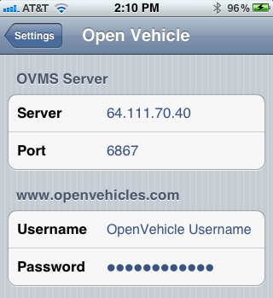There are 4 fields to enter:

**Server**: Enter the same Server IP Address you used in Step 9’s SERVER command.

**Port**: Leave at the default 6867

**Username**: Enter OpenVehicle Username you wrote down on Page 6.

**Password**: Enter the OpenVehicle Password you wrote down on Page 6.

1. Car Settings

Launch the OpenVehicle app and choose the “Settings” tab at the bottom right. Press the “New” button to create a new Car. There are 4 fields to enter here:

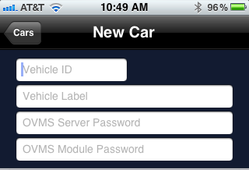

**Vehicle ID**: Enter the VehicleID you wrote down on Page 6.

**Vehicle Label**: Enter what you want your car to be called. This can be anything.

**OVMS Server Password:** Enter the OVMS Server Password you wrote down on Page 6.

**OVMS Module Password**: Enter the OVMS Module Password you wrote down on Page 6.

You can also choose a picture to represent your car.

At this point, you should be able choose the Battery, Car, and Location tabs to see information on your vehicle.

**iPhone App TroubleShooting:**

On the Battery the antenna should be solid with a green tip, and underneath should say “Live.”

If the antenna is **flashing gray**, then the App is trying to connect to the server. If it doesn’t connect after a few moments, press home and then relaunch the App.

If the antenna is **flashing green**, then the App has connected to the server, but the Module in the car is not talking with the server. Recheck the Module via the GPRS? query (see Step 11). If the Module says the Server is connected OK, then you may have a mis-match of Module/Server parameters (check vehicleID, passwords, etc.).

If the antenna is **flashing red**, then the App could not connect to the server. Double-check the Server IP and Server password.

## 14. Enable Car Control

By default OVMS is configured to only monitor the car’s state and not make changes. If you wish to control aspects of the car’s charging, change lock state, engage/disengage valet mode, or wake-up the car remotely, etc., you will first need to enable writing to the CAN bus.

You can enable the CAN Write feature by sending the following Text Message from the registered cell phone:

FEATURE 15 1

To disable CAN Write via SMS, send the following Text Message from the registered cell phone:

FEATURE 15 0

CAN Write can alternatively be enabled via some of the smartphone Apps using the “Feature” setting page. On the current iPhone application, that’s accessed off of the “Control” panel, which is gotten by going to the “Settings” tab at the bottom, clicking the “(>)” button to view/edit the car’s settings, clicking the “Control” button at the top right, and then clicking the “Features” button. Change to value to 0 or 1 as desired, then return to the Control page.

## 15. Identify your car as a v1.5 Tesla Roadster

By default, OVMS is set to work with v2.0 and later Tesla Roadsters. If you are installing the OVMS module in a v1.5 Roadster, you **must** tell it that your car is a v1.5, otherwise the charge status messages will not be correctly interpreted.

You can do this in one of two ways:

1. Send the following Text Message from the registerd cell phone to the car

FEATURE 14 1

1. Using the OVMS smartphone App (Android or Apple iOS), set Feature #14 to 1.

You do not need to reset the module after changing this feature. Note that OVMS module firmware v1.2.2 and later support is required for v1.5 Roadster support.

See Appendix B for additional values supported by Feature #14 for any car (not just v1.5s):

Add 2 to supress “Access Denied” SMS responses

Add 4 to supress all outbond SMS messages.

## 16. Share your Location using Social Groups

If you wish, you can share your location with other OpenVehicle smartphone App users. There are 2 steps to doing this:

1. Set one or more groups names for your car
2. Tell others to add the group name to their Location tab.

To set the group name for your car:

1. Start the OpenVehicle app.
2. Choose the *Settings* tab.
3. Click the *Control* button.
4. Click the *Parameters* button.
5. Enter a Social Group name for parameter #11. You can set another name in parameter #12

Tell users with whom you want to share your location:

1. Start the OpenVehicle app.
2. Choose the *Location* tab.
3. Click the *Groups* button.
4. Click the *Edit* button.
5. Click to the left of the “+” button to bring up the keyboard to enter the Social Group name.
6. Slide the associated toggle switch to “ON”.
7. Click the *Done* button.

Now they will see your car’s location on their Location page. Your car will be identified by its VehicleID.

If you no longer wish to share your car’s location, remove the associated Social Group name from your car’s Parameter #11 or #12.

## 17. Mount the OVMS Module

The OVMS Module is best secured to the front wall of the passenger footwell using the adhesive velcro tape provided. With the module connected to the CAN bus, experiment with various placements until you find a suitable spot. For the Velcro attachment to work, you’ll want to choose a spot on the front wall that’s flat for the entire size of the module (hint: avoid the big round black plastic thing).

Here is an example mounting of the OVMS Module in a left-hand-drive Roadster, on the front wall of the passenger (right side) footwell:

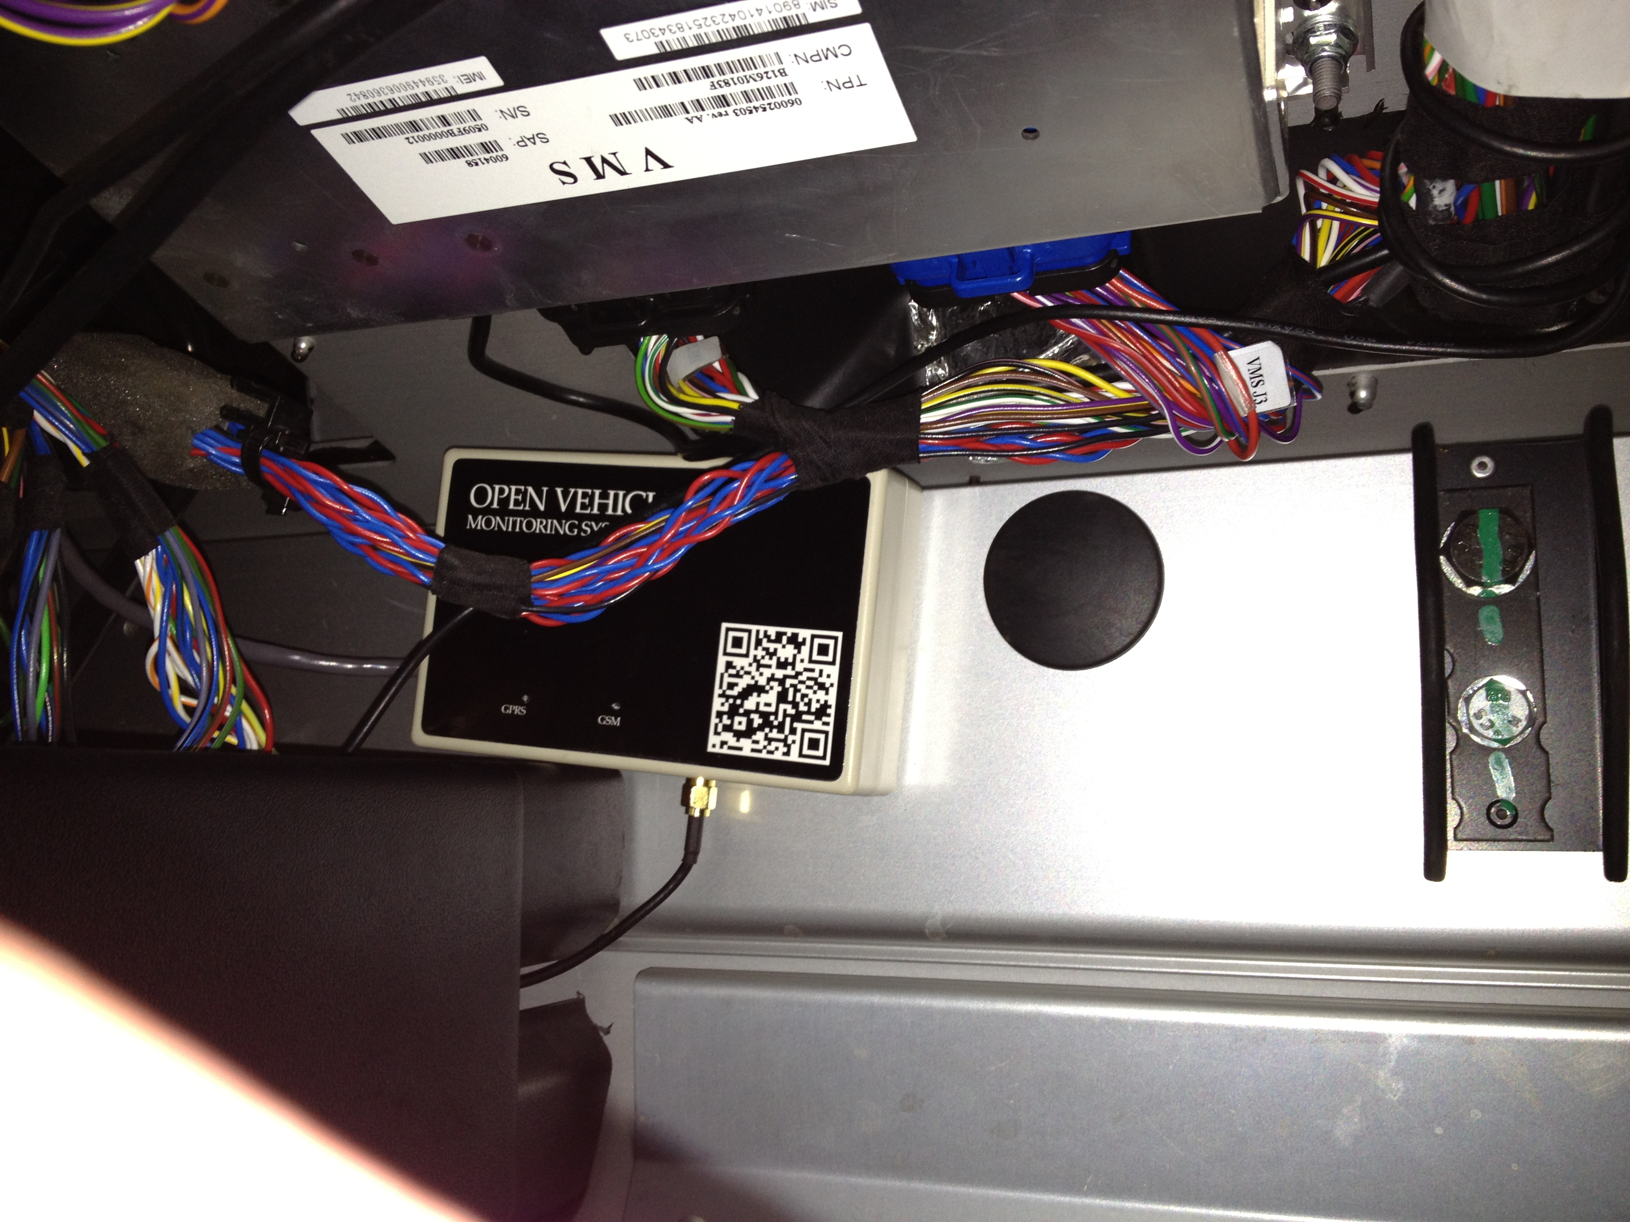 *Position of OVMS module in passenger footwell(Courtesy Michael Thwaite)*

Mounting is straightforward:

1. Ensure both velcro strips are fixed together.
2. Remove the adhesive backing from one side, and securely fasten it to the back of the OVMS module.
3. Using a clean dry cloth, clean the area of the car passenger footwell wall to which you are going to attach the module.
4. Remove the adhesive backing from the side of the velcro strip facing the car, and then firmly push the OVMS module into place - holding it still for a few seconds to allow the adhesive to work.
5. You can then remove and reinstall the OVMS module as desired via the velcro.

## 18. Locate the Antenna and Routing the Antenna cable

You will find the performance of this antenna fantastic - and much better than even your cellphone, but proper placement is essential. Since it has a very long cable, you can place the antenna just about wherever you want, but please ensure it is high-up on the car and away from any metal objects that might interfere with the signal.

Possible areas include the bottom of the windscreen/windshield on the passenger side, the top of the windscreen on the passenger side (hidden by the sun visor), behind the passenger on the side pillar, in the rear window, or under the dashboard (for the brave and experienced at dismantling Tesla Roadster dashboards).

**Example A: Bottom of the windscreen/windshield on the passenger side**

In a Right-Hand-Drive car (passenger on the left), it looks like this:

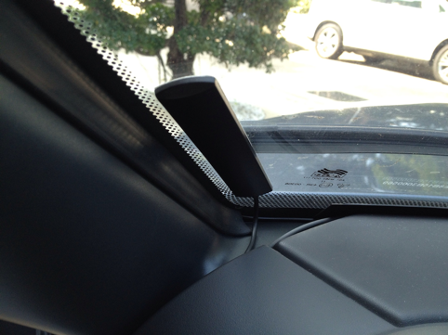

*Example antenna placement in a right-hand-drive car (left-hand-side passenger)*

To route the antenna cable, you will need to remove the fuse-box cover (one screw that needs to be turned 90degrees - marked with the top red arrow in the picture below), then two screws from the box below the fuse box (these screws should be completely removed in order to be able to remove the box and access the compartment beneath). You do not need to adjust anything in the fuse box - you only need the cover removed to make it easier to route the cable.

Start with the cable at the windscreen/windshield and route it down the side of the passenger door front pillar. The plastic corner marked with the green arrow in the picture below can be pulled back slightly, and you can push the cable through into the open bottom compartment. Pull the cable through there so that the antenna is where you want it and there is no loose cable outside the box. The antenna itself can be mounted to the windscreen/windshield by first cleaning the area with a clean dry cloth, removing the adhesive backing tape, then firmly pushing the antenna against the glass and waiting a few seconds for the adhesive to stick.

Now for the tricky bit. You need to get the cable through to the passenger footwell, but it is tight. It is much easier to get a guide wire up into the fuse box compartment than to get the antenna cable down into the passenger footwell. So, we recommend you use a small (12inches / 30cm or so) piece of stiff wire to use as a guide and push it up from the area marked by the green arrow on the bottom right of the picture below. Once the guide wire is in the fuse box, push it down into the lower compartment you opened and wrap it around the antenna cable. You can then pull the guide wire back down into the passenger footwell, bringing the antenna cable with it.

The antenna cable can then be screwed in to the OVMS module. You can then tidy up any loose cable, and screw-back the lower compartment box (two screws) and fuse box cover (one screw 90degrees to lock).

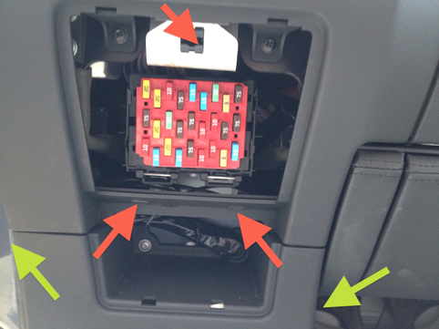

*Access and routing beneath fuse box in a right-hand drive car (left-hand-side passenger)*

**Example B: Beside the passenger headrest**

A few users have reported that the antenna cable is long enough to reach back to the area around the passenger head. This approach doesn't require a guide wire to route the antenna cable through the waterfall area (which may be quite inflexible in carbon fibre).

The module is placed in the passenger footwell, near the DIAG port connector. From there, the antenna cable is routed through the base of the waterfall, under the door sill, and up the side of the door frame.

The door sill is held in place by velcro and is easily removed. You may have to loosen the “waterfall” (held in place by four screws around the fuse box area). The antenna cable can then be placed on top of the metal of the chassis sill, between the velcro strips, and routed up through the existing plastic trunking. At this point, the door sill can then be put back in place.

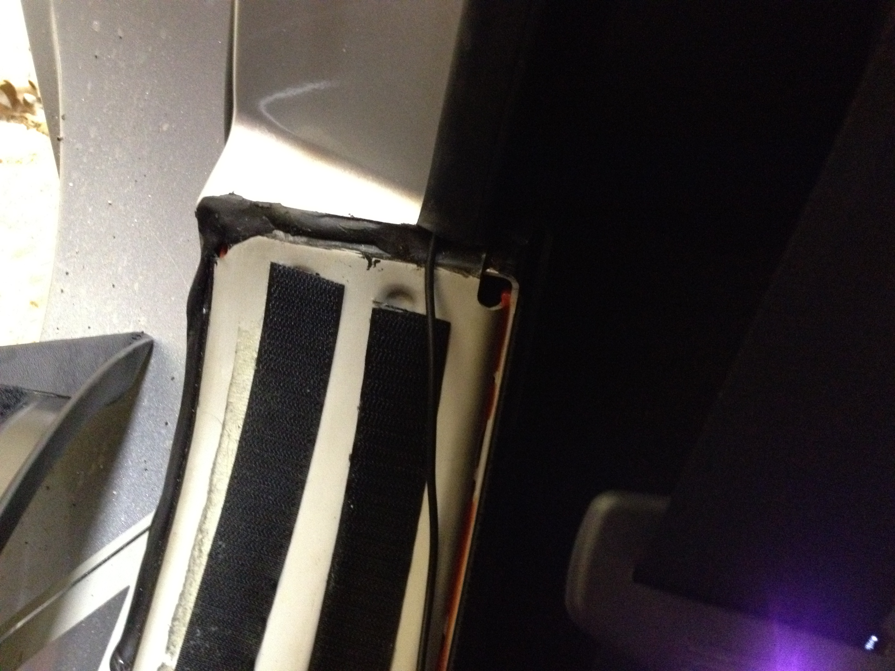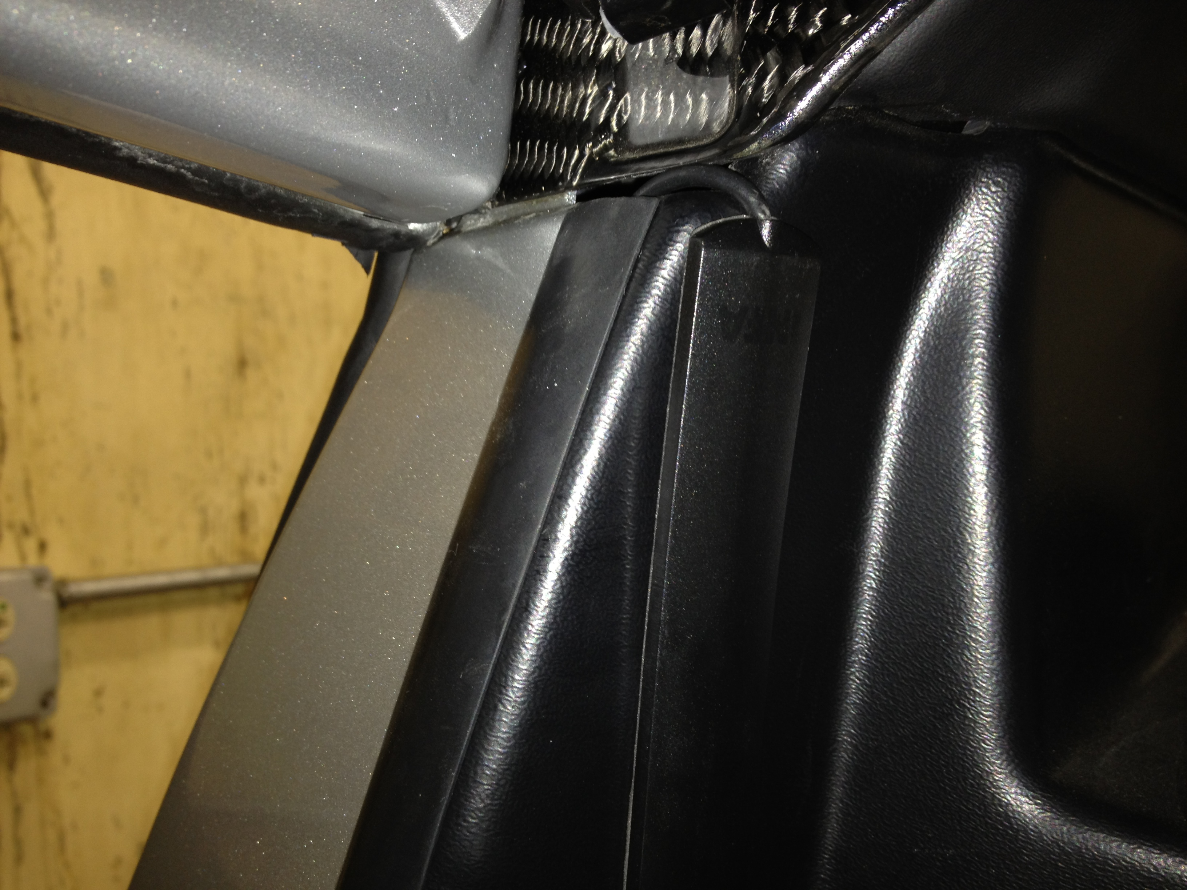*Antenna placement Routing of cable in door sill and up into plastic trunking*

The antenna can either be placed on the plastic beside the door near the passenger's head, or further back in the rear window of the car.

**Thanks**

So many people to thank: W.Petefish for sourcing the car connector, Fuzzylogic for the original hardware and software design and demonstration of it working, Scott451 for figuring out many of the Roadster CAN bus messages, Tom Saxton for v1.5 Roadster testing, Michael Thwaite for pictures of antenna installation, Bennett Leeds for wordsmithing the manual, and many others for showing that this kind of thing can work in the real world.

The Open Vehicles Team

# Appendices

## Appendix A – SMS Commands

The following table lists the supported SMS commands:

| Command | Function |
| --- | --- |
| REGISTER <password> | Register the calling telephone as the owner's telephone. The given <password> must match that stored in the phone (the factory default password is “OVMS”). See Step #6. |
| PASS <password> | Change the OVMS Module Password to <password>. This command can only be issued from the previously registered phone. We recommend that all owners change the default password upon first installation of the module in the car. See Step #67. |
| PASS? | Request an SMS reply containing OVMS Module Password. |
| STAT? | Request an SMS reply containing charge and battery status. |
| GPS? | Request an SMS reply containing a Google Map link indicating the car's position (as last reported by the car's GPS). |
| RESET *<password>* | Reboots the OVMS module. If not sent from the Registered cellphone, <password> is required. |
| MODULE <vehicleid> <units> <notificationMechanism> | Sets the Module’s parameters: VehicleID, Units, and Notification Mechanism.  <vehicleid> is what was registered with OpenVehicles.com.  <units> is either M or K or miles or kilometers, respectively.  <notificationMechanaism> is one of:  SMS to get Text Messages notifications  IP to get Push notifications in the smartphone Apps  SMSIP to get both SMS and App notifications  - to get no notifications.  This command can only be issued by the registered phone. |
| MODULE? *<password>* | Request an SMS containing the Module’s parameters. If not sent from the Registered cellphone, <password> is required. |
| SERVER <serverip> <serverpass> <paranoid> | Sets the Server Connection Parameters.  <serverip> is the IP address of the server  <serverpass> is the OVMS Server Password  <paranoid> is “P” to enable and “-“ to disable paranoid mode. |
| SERVER? *<password>* | Request an SMS containing the Server Connection parameters. If not sent from the Registered cellphone, then <password> is required. |
| GPRS <apn> <gprsuser> <gprspass> | Sets the GPRS parameters.  <apn> is the APN network to use (cellular provider supplied).  <apnuser> is the APN username.  <apnpass> is the APN password. |
| GPRS? *<password>* | Request an SMS containing the APN parameters and Server Connection status. If not sent from the Registered cellphone, then <password> is required. |
| FEATURE <feature> <value> | Set the specified feature # to the specified value. See Appendix B for the supported features and possible values. This command can only be issued by the registered phone. |
| LOCK <VDS PIN> | Locks the car. <VDS PIN> is the 6 digit PIN you previously manually set in your Tesla via the VDS. This command can only be issued by the registered phone, and it only works if CAN Write has been enabled (see Step 14). |
| UNLOCK <VDS PIN> | UnLocks the car. <VDS PIN> is the 6 digit PIN you previously manually set in your Tesla via the VDS. This command can only be issued by the registered phone, and it only works if CAN Write has been enabled (see Step 14). |
| VALET <VDS PIN> | Puts the car into Valet mode (restricted power and speed). <VDS PIN> is the 6 digit PIN you previously manually set in your Tesla via the VDS. This command can only be issued by the registered phone, and it only works if CAN Write has been enabled (see Step 14). |
| UNLOCK <VDS PIN> | Takes the car out of Valet mode. <VDS PIN> is the 6 digit PIN you previously manually set in your Tesla via the VDS. This command can only be issued by the registered phone, and it only works if CAN Write has been enabled (see Step 14). |
| HOMELINK <deviceNumber> | Activates a homelink device. <deviceNumber> is 0, 1, or 2. This command can only be issued by the registered phone. |
| CHARGEMODE <mode> <current> | Sets the Charging Mode to one of: STANDARD, STORAGE, RANGE, or PERFORMANCE and sets the maximum charging current to <current>, an integer. This command can only be issued by the registered phone |
| CHARGESTART *<password>* | If the car is plugged in, starts charging immediately. If not sent from the Registered cellphone, then <password> is required. |
| CHARGESTOP *<password>* | If the car is charging in, stops charging immediately. If not sent from the Registered cellphone, then <password> is required. |
| VERSION *<password>* | Returns the module’s firmware version. If not sent from the Registered cellphone, then <password> is required. |

## Appendix B – Feature List

The following table lists the supported features and values

| Feature # | Function |
| --- | --- |
| 0 | Experimental: Digital speedometer function. The value >0 will enable this feature and specify the aggressiveness of the function. |
| 1 | n/a |
| 2 | n/a |
| 3 | n/a |
| 4 | n/a |
| 5 | n/a |
| 6 | n/a |
| 7 | n/a |
| 8 | Location streaming feature. If this is enabled (value >0), when one or more Apps are connected, the car will stream the GPS location in real-time. Without this enabled, the location will be sent once per minute. Note that this may increase GPRS network usage. |
| 9 | Minimum SOC. If this is enabled (value >0 and <=100), when the car SOC falls to the defined value an SMS/PUSH alert notification will be sent. |
| 10 | n/a |
| 11 | n/a |
| 12 | n/a |
| 13 | n/a |
| 14 | Car Bits: A bitmap. The values are derived by adding together the following sub-values:  1 – Add 1 if this is a 2008 (v1.x) Tesla Roadster.  2 – Add 2 to suppress “Access Denied” SMS responses  4 – Add 4 to suppress all outbound SMS messages |
| 15 | CAN Write: If this is enabled (value >0), the CAN bus is write-enabled and commands can be issued to control the car. If disabled (value=0), the can bus is kept in listen-only mode. |

Note: Features #0 through #7 are *volatile*. They are used for experimental features and their values will be set to zero whenever the module is reset or powered off. These features are typically only available in EXPERIMENTAL firmware, not in PRODUCTION firmware.

## Appendix C – Parameter List

The following table lists the Parameters (See the Control page of the smartphone Apps):

| Parameter # | Parameter | Function |
| --- | --- | --- |
| 0 | Registered Telephone | The phone number of the registered cell phone |
| 1 | Module Password | OVMS Module Password |
| 2 | Miles/Km | “M” for miles, or “K” for kilometers |
| 3 | Notifications | Notification method: “SMS”, “IP”, “SMSIP”, or “-“ |
| 4 | OVMS Server IP | OVMS Server IP Address |
| 5 | Cellular Network APN | Cellular Network APN |
| 6 | Cellular Network User | Cellular Network Username |
| 7 | Cellular Network Password | Cellular Network Password |
| 8 | Vehicle ID | VehicleID |
| 9 | Server Password | OVMS Server Password |
| 10 | Paranoid Mode | “P” for paranoid mode, blank or “-“ otherwise |
| 11 | Social Group #1 | Social Group #1 name |
| 12 | Social Group #2 | Social Group #2 name |
| 13 | n/a | n/a |
| 14 | n/a | n/a |
| 15 | n/a | n/a |
| 16 | n/a | n/a |
| 17 | n/a | n/a |
| 18 | n/a | n/a |
| 19 | n/a | n/a |
| 20 | n/a | n/a |
| 21 | n/a | n/a |
| 22 | n/a | n/a |
| 23 | n/a | n/a |
| 24 | n/a | n/a |